Example software development project

William Roebuck

Contents

Analysis 2

The problem 2

Stakeholders 2

Research 2

Essential Features 3

Hardware and Software Requirements 3

Success Criteria 3

Design 4

Decomposition 4

Structure 4

Algorithms 4

Usability features (GUI) 4

Data structures 5

Test data 5

Post development testing 5

Implementation 6

Iteration 1 6

Prototype 1.1 code 6

Prototype 1.1 testing 6

Prototype 1.2 code 6

Prototype 1.2 testing 6

Iteration 2 6

Prototype 2.1 code 6

Prototype 2.1 testing 6

Prototype 2.2 code 6

Prototype 2.2 testing 6

Iteration 3 6

Prototype 3.1 code 6

Prototype 3.1 testing 6

Prototype 3.2 code 6

Prototype 3.2 testing 6

Prototype 3.3 code 6

Prototype 3.3 testing 6

Evaluation 6

Testing for function 6

Testing for robustness 6

Testing for usability 7

Success Criteria 7

Further development 7

Maintenance 8

# Analysis

## The problem

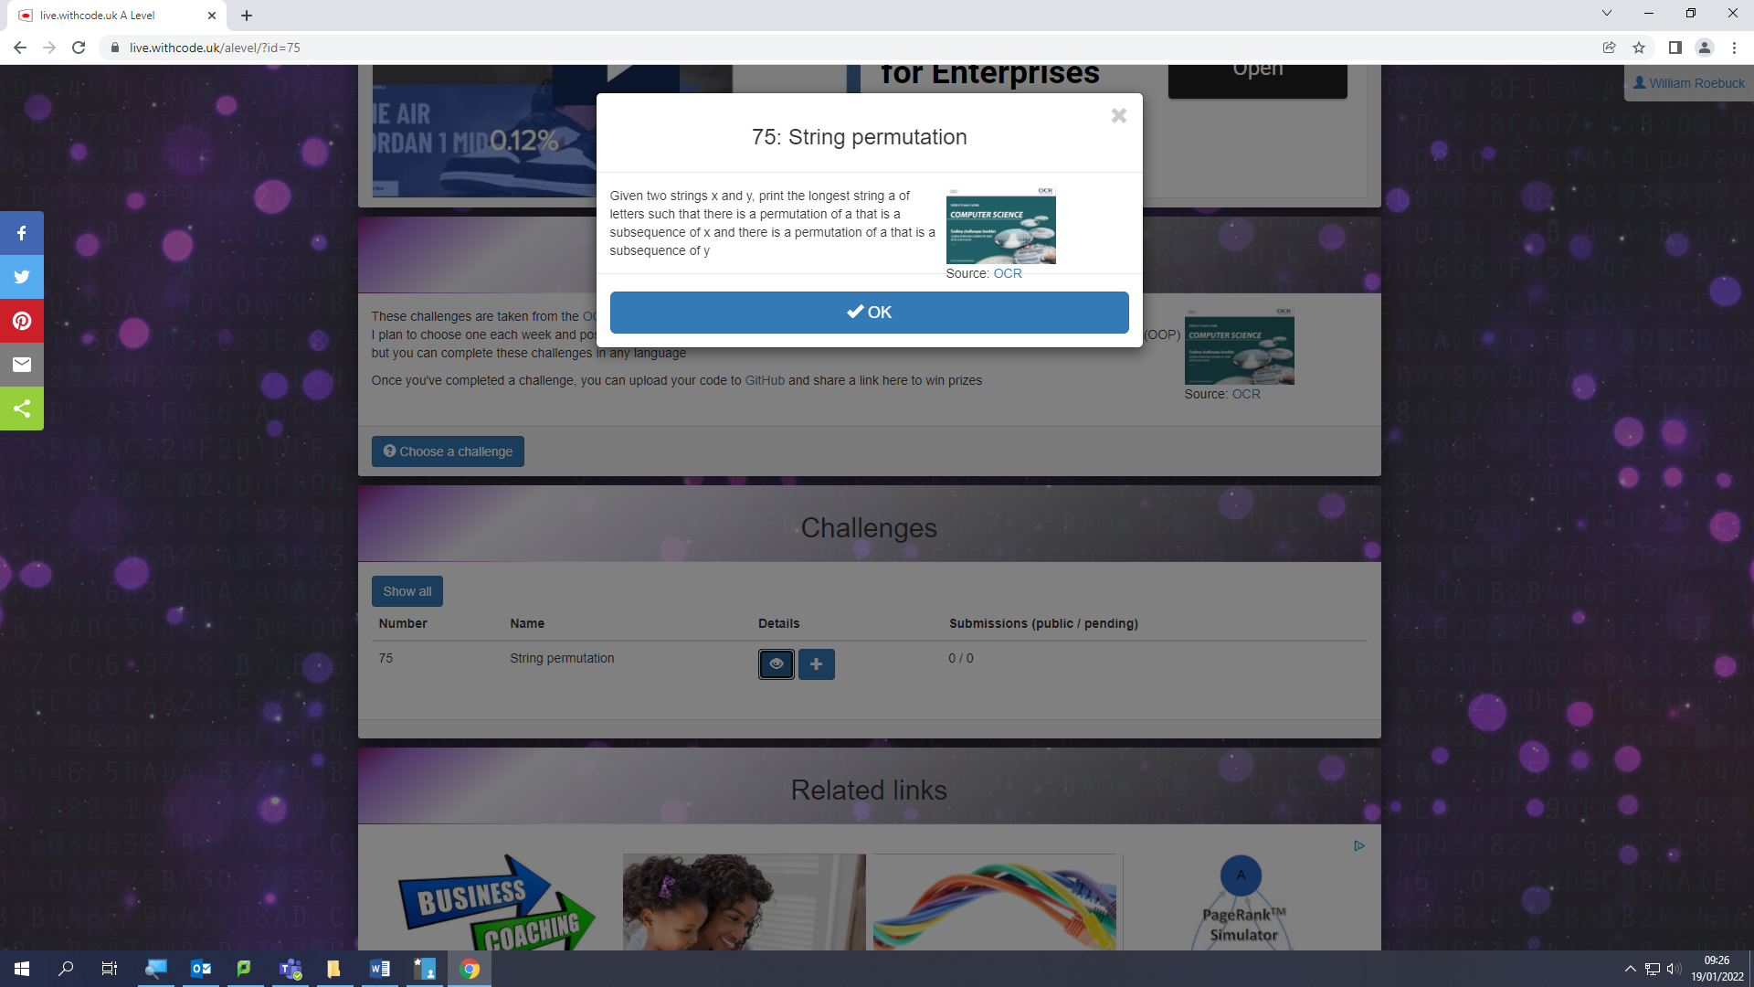

Lorem ipsum dolor sit amet, consectetuer adipiscing elit. Maecenas porttitor congue massa. Fusce posuere, magna sed pulvinar ultricies, purus lectus malesuada libero, sit amet commodo magna eros quis urna.

Nunc viverra imperdiet enim. Fusce est. Vivamus a tellus.

Pellentesque habitant morbi tristique senectus et netus et malesuada fames ac turpis egestas. Proin pharetra nonummy pede. Mauris et orci.

Aenean nec lorem. In porttitor. Donec laoreet nonummy augue.

Suspendisse dui purus, scelerisque at, vulputate vitae, pretium mattis, nunc. Mauris eget neque at sem venenatis eleifend. Ut nonummy.

## Stakeholders

Lorem ipsum dolor sit amet, consectetuer adipiscing elit. Maecenas porttitor congue massa. Fusce posuere, magna sed pulvinar ultricies, purus lectus malesuada libero, sit amet commodo magna eros quis urna.

Nunc viverra imperdiet enim. Fusce est. Vivamus a tellus.

Pellentesque habitant morbi tristique senectus et netus et malesuada fames ac turpis egestas. Proin pharetra nonummy pede. Mauris et orci.

Aenean nec lorem. In porttitor. Donec laoreet nonummy augue.

Suspendisse dui purus, scelerisque at, vulputate vitae, pretium mattis, nunc. Mauris eget neque at sem venenatis eleifend. Ut nonummy.

## Research

Lorem ipsum dolor sit amet, consectetuer adipiscing elit. Maecenas porttitor congue massa. Fusce posuere, magna sed pulvinar ultricies, purus lectus malesuada libero, sit amet commodo magna eros quis urna.

Nunc viverra imperdiet enim. Fusce est. Vivamus a tellus.

Pellentesque habitant morbi tristique senectus et netus et malesuada fames ac turpis egestas. Proin pharetra nonummy pede. Mauris et orci.

Aenean nec lorem. In porttitor. Donec laoreet nonummy augue.

Suspendisse dui purus, scelerisque at, vulputate vitae, pretium mattis, nunc. Mauris eget neque at sem venenatis eleifend. Ut nonummy.

## Essential Features

Lorem ipsum dolor sit amet, consectetuer adipiscing elit. Maecenas porttitor congue massa. Fusce posuere, magna sed pulvinar ultricies, purus lectus malesuada libero, sit amet commodo magna eros quis urna.

Nunc viverra imperdiet enim. Fusce est. Vivamus a tellus.

Pellentesque habitant morbi tristique senectus et netus et malesuada fames ac turpis egestas. Proin pharetra nonummy pede. Mauris et orci.

Aenean nec lorem. In porttitor. Donec laoreet nonummy augue.

Suspendisse dui purus, scelerisque at, vulputate vitae, pretium mattis, nunc. Mauris eget neque at sem venenatis eleifend. Ut nonummy.

## Hardware and Software Requirements

Lorem ipsum dolor sit amet, consectetuer adipiscing elit. Maecenas porttitor congue massa. Fusce posuere, magna sed pulvinar ultricies, purus lectus malesuada libero, sit amet commodo magna eros quis urna.

Nunc viverra imperdiet enim. Fusce est. Vivamus a tellus.

Pellentesque habitant morbi tristique senectus et netus et malesuada fames ac turpis egestas. Proin pharetra nonummy pede. Mauris et orci.

Aenean nec lorem. In porttitor. Donec laoreet nonummy augue.

Suspendisse dui purus, scelerisque at, vulputate vitae, pretium mattis, nunc. Mauris eget neque at sem venenatis eleifend. Ut nonummy.

## Success Criteria

|  |  |  |
| --- | --- | --- |
| No. | Criteria | Justification |
| 1 | It must have a GUI | It needs to be user friendly to a wide range of people |
| 2 | User must be able to input string x | This allows the user to choose any string they want |
| 3 | User must be able to input string y | This allows the user to choose any string they want |
| 4 | Program must display the longest sequence of letters shared by both strings | This shows the user the data they require |
| 5 | If either string is left empty, an error message should ask the user to enter the string |  |
| 6 | Program should display a message if no letters are shared |  |
| 7 | Must function on a windows 10 computer with a resolution of 1920x1080 |  |
| 8 | Must work with any valid ascii character |  |

Lorem ipsum dolor sit amet, consectetuer adipiscing elit. Maecenas porttitor congue massa. Fusce posuere, magna sed pulvinar ultricies, purus lectus malesuada libero, sit amet commodo magna eros quis urna.

Nunc viverra imperdiet enim. Fusce est. Vivamus a tellus.

Pellentesque habitant morbi tristique senectus et netus et malesuada fames ac turpis egestas. Proin pharetra nonummy pede. Mauris et orci.

Aenean nec lorem. In porttitor. Donec laoreet nonummy augue.

Suspendisse dui purus, scelerisque at, vulputate vitae, pretium mattis, nunc. Mauris eget neque at sem venenatis eleifend. Ut nonummy.

# Design

## Decomposition

Lorem ipsum dolor sit amet, consectetuer adipiscing elit. Maecenas porttitor congue massa. Fusce posuere, magna sed pulvinar ultricies, purus lectus malesuada libero, sit amet commodo magna eros quis urna.

Nunc viverra imperdiet enim. Fusce est. Vivamus a tellus.

Pellentesque habitant morbi tristique senectus et netus et malesuada fames ac turpis egestas. Proin pharetra nonummy pede. Mauris et orci.

Aenean nec lorem. In porttitor. Donec laoreet nonummy augue.

Suspendisse dui purus, scelerisque at, vulputate vitae, pretium mattis, nunc. Mauris eget neque at sem venenatis eleifend. Ut nonummy.

## Structure

Spiral iterative approach

Iteration 1

Prototype 1.1: user interface with no functionality

Prototype 1.2: user input with validated user input

Iteration 2

Prototype 2.1: Calculation for normal data

Prototype 2.2: Calculation for all data

Prototype 2.3: Fully working solution with help screen

## Algorithms

Function Validate(string userInput)

{

//Presence check

//Length check

}

## Usability features (GUI)

Lorem ipsum dolor sit amet, consectetuer adipiscing elit. Maecenas porttitor congue massa. Fusce posuere, magna sed pulvinar ultricies, purus lectus malesuada libero, sit amet commodo magna eros quis urna.

TITLE

Nunc viverra imperdiet enim. Fusce est. Vivamus a tellus.

String x input

Pellentesque habitant morbi tristique senectus et netus et malesuada fames ac turpis egestas. Proin pharetra nonummy pede. Mauris et orci.

String y input

Aenean nec lorem. In porttitor. Donec laoreet nonummy augue.

Calculate!

Output box

Suspendisse dui purus, scelerisque at, vulputate vitae, pretium mattis, nunc. Mauris eget neque at sem venenatis eleifend. Ut nonummy.

Options

New world

Start

## Data structures

|  |
| --- |
| ValidationResult |
| +ValidationSuccess:bool  +message:string |
| +ValidateUserInput() |

## Test data

|  |  |  |  |  |
| --- | --- | --- | --- | --- |
| No. | Description | Test data | Expected Result | Success Criteria |
| 1.1a | User interface | Start the program | User should be able to enter 2 strings and press a button | 1, 2, and 3 |
| 1.2a | Test string X’s presence check | User enters “” for string X | Program should display a message asking the user to enter a valid string | 2 and 5 |
| 1.2b | Test string X’s length check (acceptable value) | User enters 1024 1s for string X | Program should validate successfully | 2 and 8 |
| 1.2c | Test string X’s length check (invalid value) | User enters 1025 1s for string X | Program should display a message asking the user to enter a valid string | 2 and 8 |
| 1.2d | Test string X’s Unicode check | User enters ‘☺’ as string X | Program should display a message asking the user to enter a valid string | 2 and 8 |
| 1.2e | Test string Y’s presence check | User enters “" for string Y | Program should validate successfully | 2 and 8 |

## Post development testing

Lorem ipsum dolor sit amet, consectetuer adipiscing elit. Maecenas porttitor congue massa. Fusce posuere, magna sed pulvinar ultricies, purus lectus malesuada libero, sit amet commodo magna eros quis urna.

Nunc viverra imperdiet enim. Fusce est. Vivamus a tellus.

Pellentesque habitant morbi tristique senectus et netus et malesuada fames ac turpis egestas. Proin pharetra nonummy pede. Mauris et orci.

Aenean nec lorem. In porttitor. Donec laoreet nonummy augue.

Suspendisse dui purus, scelerisque at, vulputate vitae, pretium mattis, nunc. Mauris eget neque at sem venenatis eleifend. Ut nonummy.

# Implementation

## Iteration 1

### Prototype 1.1 code

### Prototype 1.1 testing

|  |  |  |  |  |
| --- | --- | --- | --- | --- |
| Test number | Test data | Expected result | Actual Result | Action taken |
| 1.1a | User enters “bob” as name | Greeting displayed “Hello Bob” | No greeting | Fix greeting |

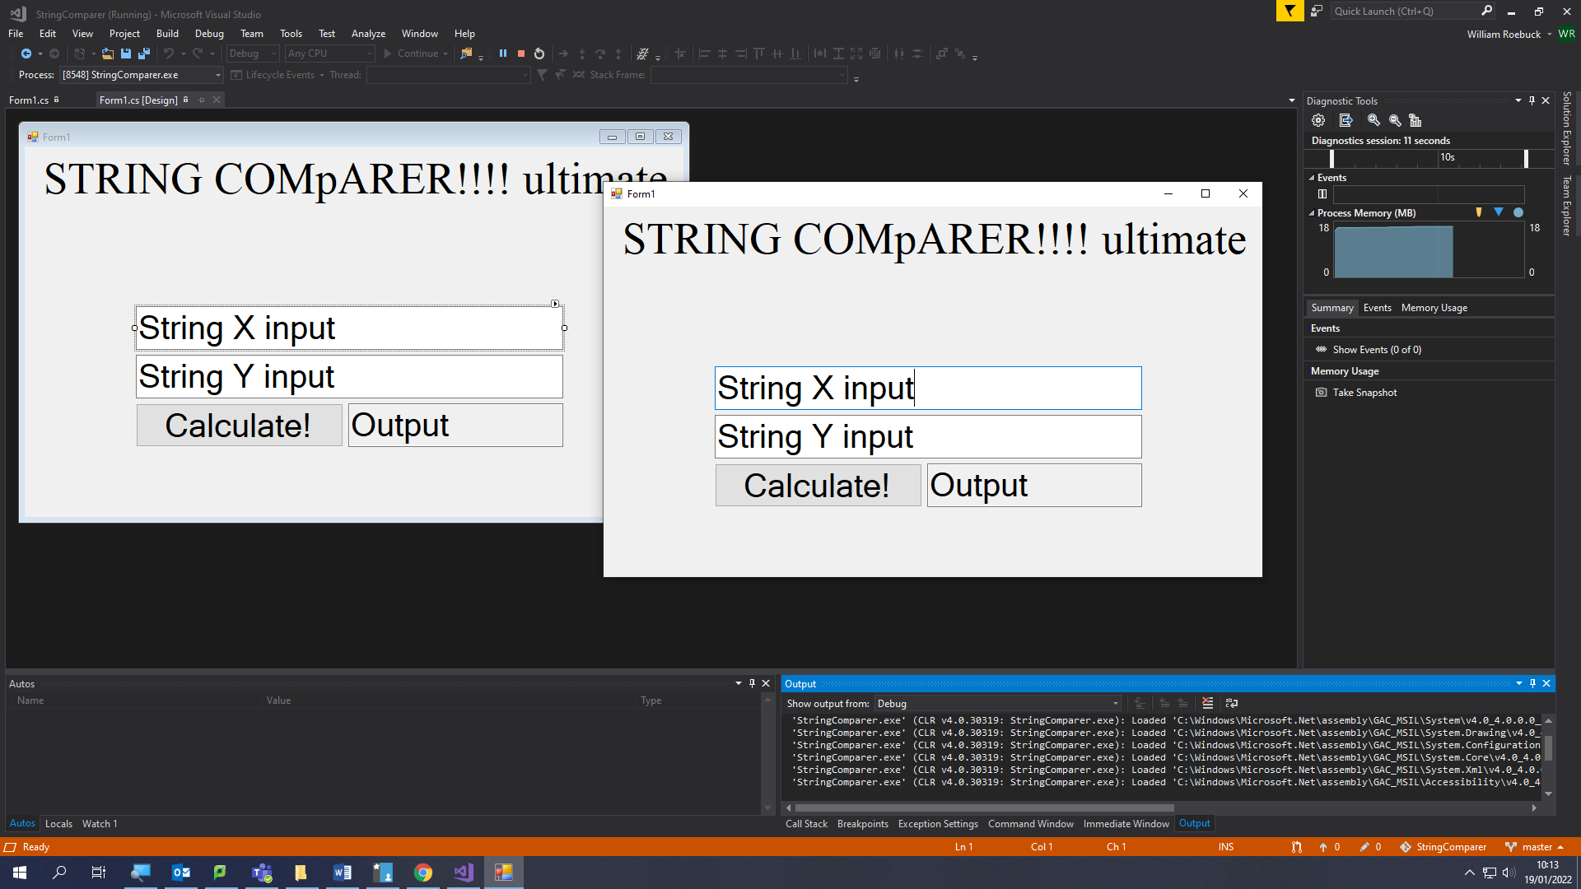To fix the greeting I set the name to a variable as shown below

### Prototype 1.2 code

### Prototype 1.2 testing

## Iteration 2

### Prototype 2.1 code

### Prototype 2.1 testing

|  |  |  |  |  |  |
| --- | --- | --- | --- | --- | --- |
| Test number | Description | Test data | Expected result | Success criteria | Actual result |
| 1.2a | Test string X’s presence check | User enters “” for string X | Program should display a message asking the user to enter a valid string | 2 and 5 | Success! See screenshot 2.1a1 below |

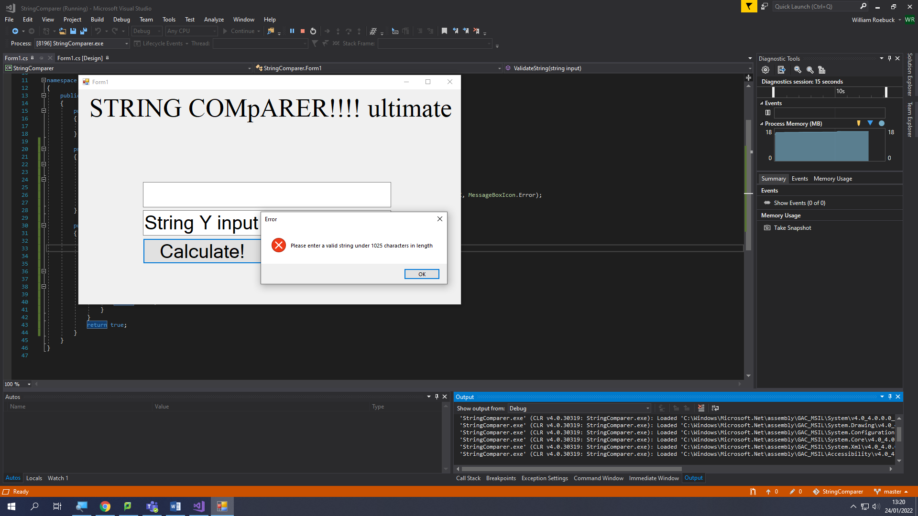

|  |  |  |  |  |  |
| --- | --- | --- | --- | --- | --- |
| Test number | Description | Test data | Expected result | Success criteria | Actual result |
| 1.2b | Test string X’s length check (acceptable value) | User enters 1024 1s for string X | Program should validate successfully | 2 and 8 | Failed! See screenshot 1.2b1 below |

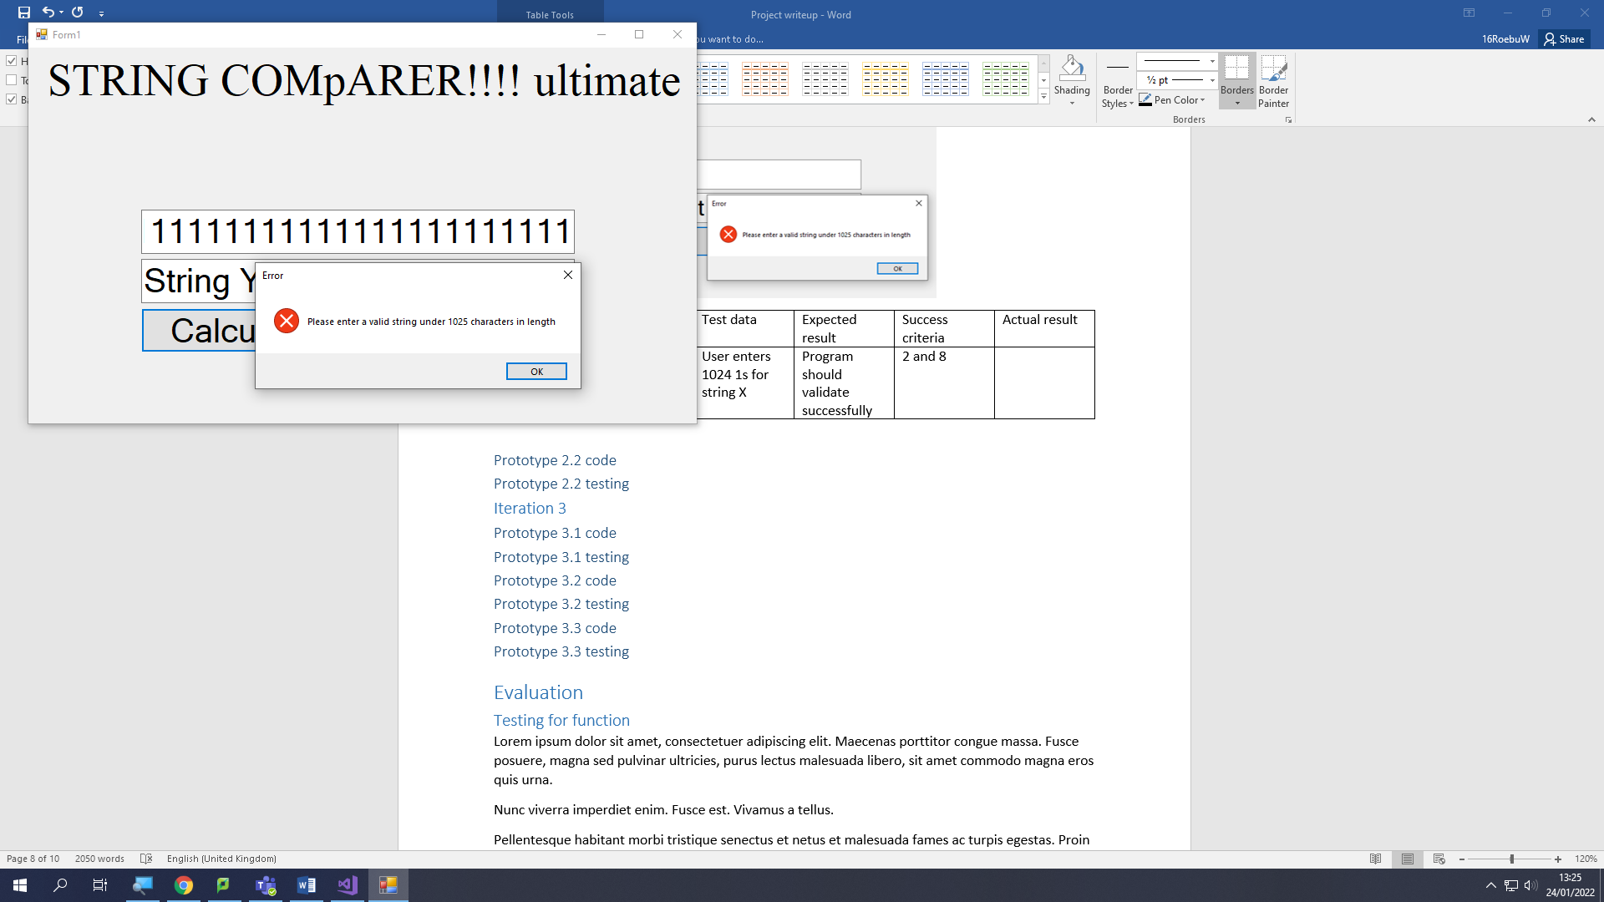

Fixed by changing code shown below from:

if (input.Length >= 1024)

return false;

to:

if (input.Length > 1024)

return false;

|  |  |  |  |  |  |
| --- | --- | --- | --- | --- | --- |
| Test number | Description | Test data | Expected result | Success criteria | Actual result |
| 1.2c | Test string X’s length check (invalid value) | User enters 1025 1s for string X | Program should display a message asking the user to enter a valid string | 2 and 8 | Success! See screenshot 1.2c1 below |

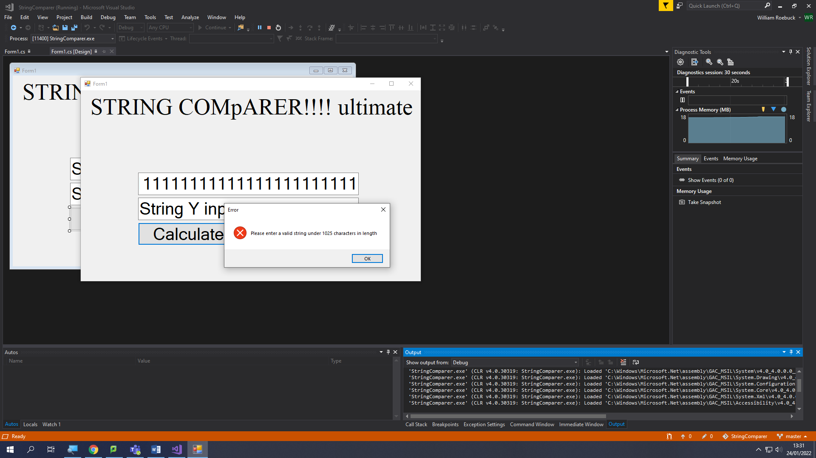

|  |  |  |  |  |  |
| --- | --- | --- | --- | --- | --- |
| Test number | Description | Test data | Expected result | Success criteria | Actual result |
| 1.2d | Test string X’s Unicode check | User enters ‘☺’ as string X | Program should display a message asking the user to enter a valid string | 2 and 8 | Success! See screenshot 1.2d1 below |

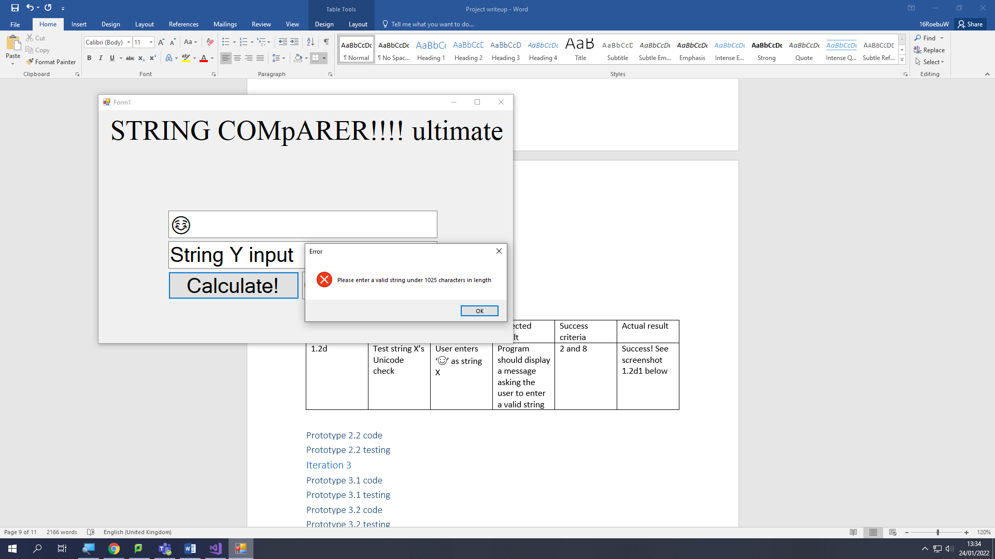

|  |  |  |  |  |  |
| --- | --- | --- | --- | --- | --- |
| Test number | Description | Test data | Expected result | Success criteria | Actual result |
| 1.2e | Test string Y’s presence check | User enters “" for string Y | Program should validate successfully | 2 and 8 | Success! See screenshot 1.2e1 below |

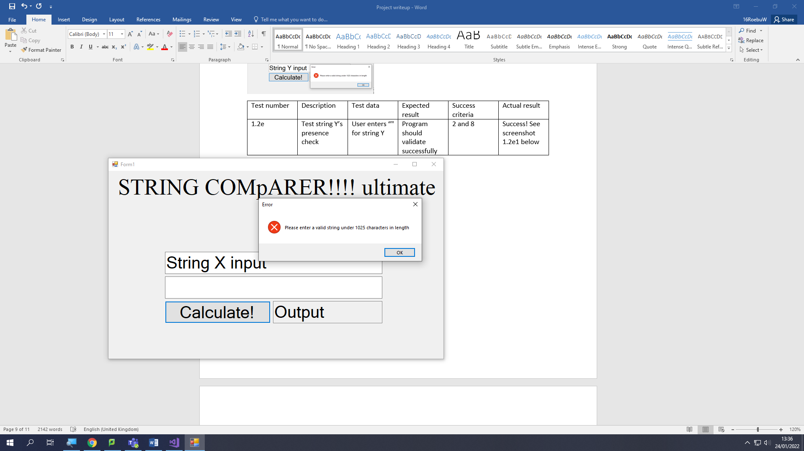

### Prototype 2.2 code

### Prototype 2.2 testing

## Iteration 3

### Prototype 3.1 code

### Prototype 3.1 testing

### Prototype 3.2 code

### Prototype 3.2 testing

### Prototype 3.3 code

### Prototype 3.3 testing

# Evaluation

## Testing for function

Lorem ipsum dolor sit amet, consectetuer adipiscing elit. Maecenas porttitor congue massa. Fusce posuere, magna sed pulvinar ultricies, purus lectus malesuada libero, sit amet commodo magna eros quis urna.

Nunc viverra imperdiet enim. Fusce est. Vivamus a tellus.

Pellentesque habitant morbi tristique senectus et netus et malesuada fames ac turpis egestas. Proin pharetra nonummy pede. Mauris et orci.

Aenean nec lorem. In porttitor. Donec laoreet nonummy augue.

Suspendisse dui purus, scelerisque at, vulputate vitae, pretium mattis, nunc. Mauris eget neque at sem venenatis eleifend. Ut nonummy.

## Testing for robustness

Lorem ipsum dolor sit amet, consectetuer adipiscing elit. Maecenas porttitor congue massa. Fusce posuere, magna sed pulvinar ultricies, purus lectus malesuada libero, sit amet commodo magna eros quis urna.

Nunc viverra imperdiet enim. Fusce est. Vivamus a tellus.

Pellentesque habitant morbi tristique senectus et netus et malesuada fames ac turpis egestas. Proin pharetra nonummy pede. Mauris et orci.

Aenean nec lorem. In porttitor. Donec laoreet nonummy augue.

Suspendisse dui purus, scelerisque at, vulputate vitae, pretium mattis, nunc. Mauris eget neque at sem venenatis eleifend. Ut nonummy.

## Testing for usability

Lorem ipsum dolor sit amet, consectetuer adipiscing elit. Maecenas porttitor congue massa. Fusce posuere, magna sed pulvinar ultricies, purus lectus malesuada libero, sit amet commodo magna eros quis urna.

Nunc viverra imperdiet enim. Fusce est. Vivamus a tellus.

Pellentesque habitant morbi tristique senectus et netus et malesuada fames ac turpis egestas. Proin pharetra nonummy pede. Mauris et orci.

Aenean nec lorem. In porttitor. Donec laoreet nonummy augue.

Suspendisse dui purus, scelerisque at, vulputate vitae, pretium mattis, nunc. Mauris eget neque at sem venenatis eleifend. Ut nonummy.

## Success Criteria

Lorem ipsum dolor sit amet, consectetuer adipiscing elit. Maecenas porttitor congue massa. Fusce posuere, magna sed pulvinar ultricies, purus lectus malesuada libero, sit amet commodo magna eros quis urna.

Nunc viverra imperdiet enim. Fusce est. Vivamus a tellus.

Pellentesque habitant morbi tristique senectus et netus et malesuada fames ac turpis egestas. Proin pharetra nonummy pede. Mauris et orci.

Aenean nec lorem. In porttitor. Donec laoreet nonummy augue.

Suspendisse dui purus, scelerisque at, vulputate vitae, pretium mattis, nunc. Mauris eget neque at sem venenatis eleifend. Ut nonummy.

## Further development

Lorem ipsum dolor sit amet, consectetuer adipiscing elit. Maecenas porttitor congue massa. Fusce posuere, magna sed pulvinar ultricies, purus lectus malesuada libero, sit amet commodo magna eros quis urna.

Nunc viverra imperdiet enim. Fusce est. Vivamus a tellus.

Pellentesque habitant morbi tristique senectus et netus et malesuada fames ac turpis egestas. Proin pharetra nonummy pede. Mauris et orci.

Aenean nec lorem. In porttitor. Donec laoreet nonummy augue.

Suspendisse dui purus, scelerisque at, vulputate vitae, pretium mattis, nunc. Mauris eget neque at sem venenatis eleifend. Ut nonummy.

## Maintenance

Lorem ipsum dolor sit amet, consectetuer adipiscing elit. Maecenas porttitor congue massa. Fusce posuere, magna sed pulvinar ultricies, purus lectus malesuada libero, sit amet commodo magna eros quis urna.

Nunc viverra imperdiet enim. Fusce est. Vivamus a tellus.

Pellentesque habitant morbi tristique senectus et netus et malesuada fames ac turpis egestas. Proin pharetra nonummy pede. Mauris et orci.

Aenean nec lorem. In porttitor. Donec laoreet nonummy augue.

Suspendisse dui purus, scelerisque at, vulputate vitae, pretium mattis, nunc. Mauris eget neque at sem venenatis eleifend. Ut nonummy.